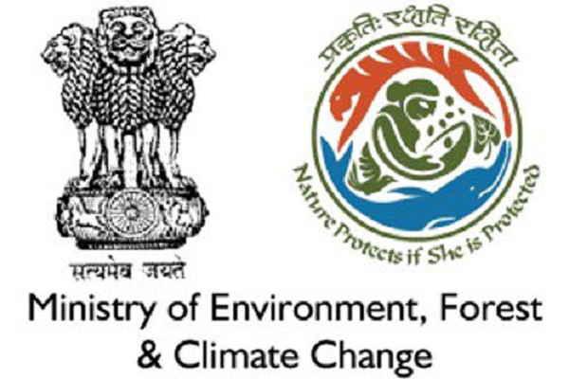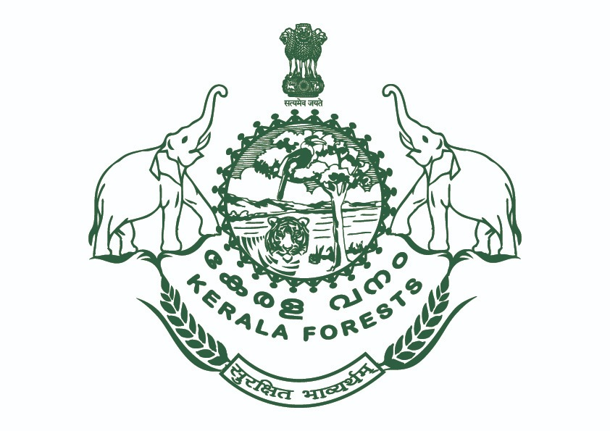

*For Immediate Release*

**“Forest-PLUS 2.0”, the Bilateral Program by USAID and MoEFCC Launches in Kerala**

**New Delhi, October 31:** Succeeding the national launch on September 25, 2019, the U.S. Agency for International Development (USAID) and the Ministry of Environment, Forest and Climate Change (MoEFCC) of India launched the bilateral program “Forest-PLUS 2.0: forest for water and propserity” at an event in Thiruvananthapuram, Kerala.

Under the joint program, USAID will provide technical assistance to Kerala Forest Department to improve the management of landscape comprising Agasthyamalai Biosphere Reserve located in the Western Ghats in Kerala. The Biosphere Reserve is globally known for its unique biophysical and ecological processes and its high montane forest ecosystems that impact India’s weather patterns.

Speaking at the launch, USAID/India Deputy Mission Director, Ramona El Hamzaoui

acknowledged USAID’s partnership with India on land management and forestry. “For decades, USAID has been privileged to partner with India to improve land management. Forest-PLUS 2.0, like its predecessor Forest-PLUS Program, once again brings together the best scientific minds from our two countries to develop tools and techniques to strengthen ecosystem-based management and the inclusion of ecosystem.” Besides Kerala, the program will also work in Bihar and Telangana.

K. Raju, Minister for Forests, Animal Husbandry, Dairy Development and Zoos, Government of Kerala, also attended the launch and remarked on the importance of this program in Kerala. He highlighted on the efforts of Kerala Government to maintain the 29 percent geographical area of the state as forest. Out of these, 1/4th of the forest area lies in the highest priority in terms of protection such as national parks and tiger reserves. He also emphasized on the importance of the Neyyar, Kallar, Vamanapuram, rivers originating from the forests of Thiruvananthapuram region.

Representatives and environment experts from government, academia, civil society, and the private sector deliberated on the region’s rich biodiversity and the role Forest-PLUS 2.0 can play in strengthening and improving the management of forests in the state through an enhanced focus on the ecosystem services. The day-long event helped the audience gain insights into the program components and how they relate to the challenges and opportunities presented by the forested landscape of Kerala. The in-depth discussion on valuation and inclusion of ecosystem services in planning and achieving economic sustainability from forest-based value chains were the major highlights of the event.

The launch program also brought to the fore the role of gender in forestry and the scope for socio-cultural ecosystem services to be developed in the landscape for the large number of people who visit the forests for different purposes.

###

____________________________________________________________________________

***For more information, contact:***

Neha Khator, USAID/India, [nkhator@usaid.gov](mailto:nkhator@usaid.gov) | +91 98118 69521

Kritika Gupta, Forest-PLUS 2.0, [Kritika.Gupta@forestplus.org](mailto:Kritika.Gupta@forestplus.org) | +91 98714 66836

Almost 300 million people in India depend on forest resources for their livelihoods. While the forest cover is stable, the unsustainable use of forest resources continues to degrade the forests.